Fuel Consumption Analysis System Using Python
REPORT

CSA0806– PYTHON PROGRAMMING
Course Outcomes: CO1, CO2, CO3 and CO4

Submitted by
Name: G. Umesh Chandra Yadav Register No.: 192525424 Department: B. Tech AI&ML
Year / Semester: 2

Submitted to
Faculty Name: Dr. S. Ponmaniraj
Institution: SIMATS Engineering.

Academic Year: 2026–2027

CERTIFICATE

This is to certify that G. Umesh Chandra Yadav (192525424) of B. Tech Artificial intelligence and machine learning has successfully prepared and submitted the report entitled “Fuel Consumption Analysis System Using Python” as part of the academic requirements for CSA0806-Python programming.
The work presented in this report addresses processor-based traffic sensing, peripheral interfacing, signal control, interrupt handling, timing, emergency-vehicle priority, data storage and serial communication as specified in the assignment.

Faculty Signature: Dr. S. Ponmaniraj
Date: 02-09-2026

TABLE OF CONTENTS
- Abstract
- Introduction
- Problem Statement
- Objectives
- Requirements
- Application of Relevant Course Knowledge
- Proposed System and Methodology
- Pseudocode
- Implementation and Source Code
- Test Cases and Expected/Actual Results
- Results and Validation
- Comparison and Justification
- SDG Relevance
- Conclusion
- Individual Contribution of Group Members
- Individual Reflection
- References

Problem Statement and Problem Formulation
Vehicle owners and small fleet operators commonly track fuel usage manually using notebooks or spreadsheets. This manual approach makes it difficult to identify which vehicles are consuming fuel inefficiently, to detect individual trips that consume abnormally high amounts of fuel, and to obtain a consolidated view of fleet performance over time. As the number of vehicles or trips grows, manual record-keeping becomes error-prone, time-consuming, and unsuitable for generating reliable analytical reports.
The specific problems addressed by this project are:
- Manual fuel-consumption tracking is tedious and prone to calculation errors.
- It is difficult to identify inefficient vehicles without systematically comparing mileage figures.
- Wasteful or abnormally high-consumption trips often go unnoticed until fuel costs become significant.
- Automated calculation of mileage (km/L), monthly consumption, and fuel cost is required for accurate decision-making.
- Fuel cost estimation must reflect the current price of fuel entered by the user.
- Vehicle and trip records must be organised systematically for filtering, grouping and summarising.
- Persistent storage is required so that records are not lost between program runs.
- A consolidated report is required to summarise fleet performance for review.
Based on the above, the computational problem is formulated as follows: design and implement a menu-driven Python console application that allows a user to register vehicles, record refuelling and trip data, and automatically compute mileage, monthly consumption and fuel cost, while persisting all data to CSV files and generating a consolidated analysis report that highlights the most and least fuel-efficient vehicles and any abnormal-consumption trips.

Problem Formulation Table

Aspect | Description
Inputs | Vehicle number, vehicle type, fuel type, refuelling quantity (L), fuel price (Rs./L), trip distance (km), fuel used per trip (L), dates
Processing | Input validation, mileage calculation, fuel cost calculation, monthly aggregation, vehicle ranking, abnormal-trip detection, report generation
Outputs | Vehicle-wise mileage, fuel cost, monthly consumption summary, efficiency ranking, abnormal-trip list, consolidated text report
Users | Individual vehicle owners; small fleet operators/administrators

Aspect | Description
Constraints | Console-based interface; CSV/text file storage; single-user, offline operation
Data Handled | Vehicle records, fuel/refuelling logs, trip logs, computed summaries

Objective and Expected Outcomes
The objective of this project is to design and implement a menu-driven Python console application that supports the following functions:
- Register vehicles with unique vehicle numbers
- Record fuel/refuelling information for each vehicle
- Record trip information (distance travelled and fuel used)
- Calculate mileage in kilometres per litre (km/L)
- Calculate estimated fuel cost using the entered fuel price
- Calculate average monthly fuel consumption
- Rank vehicles by fuel efficiency
- Detect abnormal or high-consumption trips
- Store all records persistently in CSV/text files
- Generate a consolidated fleet analysis report
- Demonstrate core Python programming concepts including data structures, functions, file handling and modules

Expected Outcomes Table

Expected Outcome | Mapped CO
Menu-driven console application built using correct Python syntax and semantics | CO1
Validated vehicle/trip inputs and correctly computed fuel-efficiency metrics using functions and string handling | CO2
Vehicle, trip and summary data organised using lists, dictionaries, tuples and sets | CO3
Fuel logs persisted through file handling; logic organised into reusable custom modules | CO4

Requirements, Constraints and Assumptions

Functional Requirements

ID | Functional Requirement
FR1 | The system shall allow registration of a new vehicle with a unique vehicle number.
FR2 | The system shall allow entry of fuel/refuelling records for a registered vehicle.
FR3 | The system shall allow entry of trip records (distance and fuel used).
FR4 | The system shall calculate mileage (km/L) for each trip and vehicle.
FR5 | The system shall calculate estimated fuel cost from quantity and price.
FR6 | The system shall calculate monthly fuel consumption summaries.
FR7 | The system shall rank vehicles by fuel efficiency.
FR8 | The system shall detect trips with abnormally high fuel consumption.
FR9 | The system shall generate a consolidated analysis report.
FR10 | The system shall store and retrieve all records using CSV/text files.

Non-Functional Requirements

Quality Attribute | Description
Accuracy | Calculations for mileage, cost and consumption must be numerically correct and consistent.
Usability | The menu-driven interface must be simple and self-explanatory for a non-technical user.
Reliability | The system must handle repeated runs without losing previously stored data.
Maintainability | Code shall be organised into well-named functions and modules for easy modification.
Performance | The system shall respond to user input and generate reports without noticeable delay for typical data volumes.
Error Handling | Invalid inputs shall be detected and reported gracefully without crashing the program.

Constraints and Assumptions
    - Fuel quantity is measured in litres (L).
    - Distance is measured in kilometres (km).
    - Fuel price is entered in Indian Rupees (Rs.) per litre.
    - Only valid numeric values are accepted for distance, fuel quantity and price.
    - Vehicle numbers must follow a valid alphanumeric format (e.g., TN01AB1234).
    - CSV files are used for persistent storage; no external database is used.
    - The application runs locally through the Python interpreter (console-based, single user).
    - Abnormally high consumption is identified by comparing a trip's mileage against a threshold derived from the vehicle's average mileage (a trip is flagged when its mileage falls below 70% of the vehicle's average).

Application of Relevant Course Knowledge
The table below maps the Python programming concepts taught in CSA08 to their specific application within the Fuel Consumption Analysis System, and to the relevant Course Outcome (CO).

Python Concept | Application in the Project | Mapped CO
Syntax & Semantics | Overall program structure, statements and expressions used throughout main.py, data_manager.py and analysis.py | CO1
Variables & Data Types | Storing vehicle IDs, distances, fuel quantities, prices as int/float/str | CO1
Input/Output | input() for menu choices and record entry; print()/file writes for reports | CO1
Conditional Statements | Menu routing (if/elif/else); abnormal-trip threshold checks | CO1, CO2
Loops | Iterating over vehicle and trip lists to build summaries and reports | CO2
String Handling | Validating/cleaning vehicle numbers, trimming and upper-casing input, parsing dates | CO2
Functions | calculate_mileage(), calculate_fuel_cost(), register_vehicle(), etc. separating concerns | CO2
Lists | vehicle_list stores all vehicle dictionaries; trip lists loaded from CSV | CO3
Dictionaries | Each vehicle/trip record is a dictionary; vehicle_summary() keyed by vehicle_id | CO3
Tuples | Fuel-entry records represented as immutable tuples before being written to CSV | CO3
Sets | registered_vehicle_numbers set enforces uniqueness of vehicle numbers | CO3
File Handling | Reading/writing vehicles.csv, fuel_logs.csv, trip_logs.csv and report.txt | CO4
CSV Processing | csv.DictReader/DictWriter and csv.reader/writer used for structured storage | CO4
Exception Handling | try/except in get_valid_number() and calculate_mileage() to handle invalid input | CO2, CO4
Modules/Packages | data_manager and analysis are custom modules imported into main.py | CO4
Menu-Driven Programming | print_menu() and the main() loop implement the console interface | CO1

Design

System Architecture
The system follows a simple layered console architecture, in which user input flows through validation and business-logic layers before being persisted and reported:
+ +
| User |
+ +
| v
+ +
| Menu-Driven Console Interface |
| (main.py) |
+ +
| v
+ +
| Input Validation |
+ +
| v
+ +
| Vehicle & Trip/Fuel Management |
| (data_manager.py) |
+ +
| v
+ +
| Data Structures (list, dict, |
| tuple, set) |
+ +
| v
+ +
| Analysis & Calculations |
| (analysis.py) |
+ +
| v
+ +
| CSV / Text File Storage |
+ +
| v
+ +
| Report Generation |
+ +
Figure 5.1: System Architecture of the Fuel Consumption Analysis System

Module Design

File | Purpose
main.py | Entry point; implements the menu-driven console interface and coordinates calls to the two custom modules.
data_manager.py | Custom module responsible for registering vehicles and reading/writing vehicle, fuel and trip records to CSV files.
analysis.py | Custom module responsible for mileage/cost calculation, monthly analysis, ranking and abnormal-trip detection, and report generation.
vehicles.csv | Persistent storage of registered vehicle records.
fuel_logs.csv | Persistent storage of refuelling entries.
trip_logs.csv | Persistent storage of trip records.
report.txt | Generated consolidated analysis report.

Data Design
    - Vehicle records: represented as dictionaries with keys vehicle_id, vehicle_number, vehicle_type and fuel_type; collected in a list named vehicle_list.
    - Trip records: represented as dictionaries with keys trip_id, vehicle_id, date, distance_km and fuel_used_litres.
    - Fuel entries: represented as tuples (vehicle_id, date, quantity_litres, price_per_litre) before being written to CSV, illustrating the use of immutable records.
    - Collections: vehicle_list and lists of trip/fuel dictionaries loaded from CSV files.
    - Unique vehicle numbers: maintained in a set named registered_vehicle_numbers to prevent duplicate registration.

Processing Flow
The processing flow begins when the program starts and loads existing vehicle records from vehicles.csv. The main menu is then displayed repeatedly until the user chooses to exit. Each menu option triggers input validation, followed by the appropriate calculation and/or file-write operation. The flow is illustrated below:
START
| v
Load vehicles.csv into vehicle_list and registered_vehicle_numbers
| v
Display Main Menu < +
| v
Read user choice (1-7)
|
|
|
|
|
+-- 1: Register Vehicle --> validate --> save --+
| |

+-- 2: Add Fuel Entry --> validate --> save --+
| |
+-- 3: Add Trip Entry --> validate --> save --+
| |
+-- 4: View Ranking --> compute --> display --+
| |
+-- 5: Detect Abnormal Trips --> compute +
| |
+-- 6: Generate Report --> write report.txt --+
| |
+-- 7: Exit --> END |
(invalid choice) --> show error +
Figure 5.2: Processing Flow of the Fuel Consumption Analysis System

Pseudocode
The pseudocode below is consistent with the actual Python implementation presented in Section 7.

Program Initialisation and Menu Display
BEGIN
LOAD vehicle records FROM vehicles.csv INTO vehicle_list, vehicle_number_set REPEAT
DISPLAY menu options 1 to 7 READ choice
CALL the procedure matching choice UNTIL choice = 7 (Exit)
END

Vehicle Registration
PROCEDURE RegisterVehicle READ vehicle_number
IF vehicle_number IN vehicle_number_set THEN DISPLAY "Vehicle already registered"
RETURN
IF LENGTH(vehicle_number) < 6 THEN DISPLAY "Invalid vehicle number format" RETURN
GENERATE new vehicle_id READ vehicle_type, fuel_type
APPEND new record to vehicle_list AND vehicle_number_set WRITE record to vehicles.csv
END PROCEDURE

Fuel Entry and Trip Entry
PROCEDURE AddFuelEntry READ vehicle_id, date
READ quantity_litres (validate > 0) READ price_per_litre (validate > 0) cost <- quantity_litres * price_per_litre
WRITE (vehicle_id, date, quantity_litres, price_per_litre) to fuel_logs.csv DISPLAY cost
END PROCEDURE

PROCEDURE AddTripEntry GENERATE trip_id
READ vehicle_id, date
READ distance_km (validate > 0) READ fuel_used_litres (validate > 0)
mileage <- distance_km / fuel_used_litres WRITE trip record to trip_logs.csv DISPLAY mileage
END PROCEDURE

Input Validation
FUNCTION GetValidNumber(prompt) REPEAT
TRY
value <- CONVERT input TO number IF value <= 0 THEN RAISE error RETURN value
CATCH error
DISPLAY "Invalid input, please enter a positive number" END REPEAT
END FUNCTION

Mileage, Fuel Cost and Monthly Analysis
FUNCTION CalculateMileage(distance, fuel_used) IF fuel_used <= 0 THEN RAISE error
RETURN distance / fuel_used END FUNCTION

FUNCTION CalculateFuelCost(quantity, price) RETURN quantity * price
END FUNCTION

FUNCTION MonthlyAnalysis(trip_list) months <- EMPTY DICTIONARY
FOR EACH trip IN trip_list
month <- FIRST 7 CHARACTERS OF trip.date months[month].distance <- months[month].distance + trip.distance

months[month].fuel <- months[month].fuel + trip.fuel_used RETURN months
END FUNCTION

Vehicle Ranking and Abnormal Consumption Detection
FUNCTION RankVehicles(summary)
ranking <- LIST OF (vehicle_id, mileage) FROM summary SORT ranking BY mileage DESCENDING
RETURN ranking END FUNCTION

FUNCTION DetectAbnormalTrips(trip_list, summary) abnormal_trips <- EMPTY LIST
FOR EACH trip IN trip_list
trip_mileage <- CalculateMileage(trip.distance, trip.fuel_used) avg_mileage <- summary[trip.vehicle_id].mileage
IF trip_mileage < 0.70 * avg_mileage THEN APPEND trip TO abnormal_trips
RETURN abnormal_trips END FUNCTION

File Saving/Loading, Report Generation and Program Exit
PROCEDURE GenerateReport(vehicle_list, trip_list) summary <- VehicleSummary(vehicle_list, trip_list) ranking <- RankVehicles(summary)
abnormal <- DetectAbnormalTrips(trip_list, summary) OPEN report.txt FOR WRITING
WRITE ranking AND abnormal trips TO report.txt CLOSE report.txt
END PROCEDURE

PROCEDURE ExitProgram
DISPLAY "Exiting the Fuel Consumption Analysis System. Goodbye!" TERMINATE program
END PROCEDURE

Implementation
This section presents the complete Python implementation of the Fuel Consumption Analysis System. The project is organised into a main program and two custom modules, as shown in the folder structure below.

Project Folder Structure

fuel_consumption_analysis_system/
|-- main.py (menu-driven console application)
|-- data_manager.py (custom module: vehicle/fuel/trip storage)
|-- analysis.py (custom module: calculations & reporting)
|-- vehicles.csv (generated at runtime)
|-- fuel_logs.csv (generated at runtime)
|-- trip_logs.csv (generated at runtime)
`-- report.txt (generated at runtime)
  - data_manager.py (Custom Module)
This module demonstrates CO3 (list, dictionary, tuple and set usage) and CO4 (file handling).
"""
data_manager.py

Custom module for the Fuel Consumption Analysis System. Handles registration, storage and retrieval of vehicle, fuel and trip records using Python data structures (list, dict, tuple, set) and CSV file handling.
"""

import csv import os

VEHICLE_FILE = "vehicles.csv" FUEL_FILE = "fuel_logs.csv" TRIP_FILE = "trip_logs.csv"

# List of dictionaries -> in-memory vehicle records vehicle_list = []

# Set -> ensures vehicle numbers are unique registered_vehicle_numbers = set()

def load_vehicles():
"""Load vehicle records from CSV into vehicle_list and the set.""" vehicle_list.clear()
registered_vehicle_numbers.clear() if not os.path.exists(VEHICLE_FILE):
return
with open(VEHICLE_FILE, "r", newline="") as f:
reader = csv.DictReader(f) for row in reader:
vehicle_list.append(row) registered_vehicle_numbers.add(row["vehicle_number"])

def save_vehicle(vehicle_id, vehicle_number, vehicle_type, fuel_type):

"""Append a new vehicle record as a dictionary and persist to CSV.""" vehicle = {
"vehicle_id": vehicle_id, "vehicle_number": vehicle_number, "vehicle_type": vehicle_type, "fuel_type": fuel_type,
}
file_exists = os.path.exists(VEHICLE_FILE) with open(VEHICLE_FILE, "a", newline="") as f:
fieldnames = ["vehicle_id", "vehicle_number", "vehicle_type", "fuel_type"] writer = csv.DictWriter(f, fieldnames=fieldnames)
if not file_exists:
writer.writeheader() writer.writerow(vehicle) vehicle_list.append(vehicle)
registered_vehicle_numbers.add(vehicle_number)

def save_fuel_entry(vehicle_id, date, quantity_litres, price_per_litre): """Append a refuelling entry as a tuple record to fuel_logs.csv.""" # Tuple used to represent a single immutable fuel-entry record entry = (vehicle_id, date, quantity_litres, price_per_litre) file_exists = os.path.exists(FUEL_FILE)
with open(FUEL_FILE, "a", newline="") as f:
writer = csv.writer(f) if not file_exists:
writer.writerow(["vehicle_id", "date", "quantity_litres", "price_per_litre"]) writer.writerow(entry)

def save_trip_entry(trip_id, vehicle_id, date, distance_km, fuel_used_litres): """Append a trip record as a dictionary row to trip_logs.csv."""
trip = {
"trip_id": trip_id, "vehicle_id": vehicle_id, "date": date,
"distance_km": distance_km, "fuel_used_litres": fuel_used_litres,
}
file_exists = os.path.exists(TRIP_FILE) with open(TRIP_FILE, "a", newline="") as f:
fieldnames = ["trip_id", "vehicle_id", "date", "distance_km", "fuel_used_litres"] writer = csv.DictWriter(f, fieldnames=fieldnames)
if not file_exists:
writer.writeheader() writer.writerow(trip)

def load_trips():
"""Read all trip records from trip_logs.csv into a list of dictionaries.""" trips = []

if not os.path.exists(TRIP_FILE):
return trips
with open(TRIP_FILE, "r", newline="") as f:
reader = csv.DictReader(f) for row in reader:
trips.append(row) return trips

def load_fuel_logs():
"""Read all fuel entries from fuel_logs.csv into a list of tuples.""" logs = []
if not os.path.exists(FUEL_FILE): return logs
with open(FUEL_FILE, "r", newline="") as f: reader = csv.reader(f)
next(reader, None) # skip header for row in reader:
logs.append(tuple(row)) return logs

analysis.py (Custom Module)
This module demonstrates CO2 (functions, control flow) and CO4 (modules) by performing all calculations, ranking and report generation.
"""
analysis.py

Custom module that performs fuel-efficiency calculations, ranking, abnormal-trip detection and report generation for the Fuel Consumption Analysis System.
"""

ABNORMAL_THRESHOLD_RATIO = 0.70 # trip mileage below 70% of the # vehicle's average mileage is flagged

def calculate_mileage(distance_km, fuel_used_litres):
"""Return mileage in km/L; raises ValueError for non-positive fuel.""" if fuel_used_litres <= 0:
raise ValueError("Fuel used must be greater than zero.") return round(distance_km / fuel_used_litres, 2)

def calculate_fuel_cost(quantity_litres, price_per_litre): """Return the estimated cost of a quantity of fuel.""" return round(quantity_litres * price_per_litre, 2)

def vehicle_summary(vehicle_list, trip_list):
"""
Build a dictionary summary {vehicle_id: {...}} using distance and fuel figures aggregated from the trip list (a list of dictionaries). """
summary = {}
for vehicle in vehicle_list:
vid = vehicle["vehicle_id"]
summary[vid] = {"vehicle_number": vehicle["vehicle_number"], "total_distance": 0.0, "total_fuel": 0.0}
for trip in trip_list:
vid = trip["vehicle_id"] if vid in summary:
summary[vid]["total_distance"] += float(trip["distance_km"]) summary[vid]["total_fuel"] += float(trip["fuel_used_litres"])
for vid, data in summary.items():
data["mileage"] = calculate_mileage(data["total_distance"], data["total_fuel"]) \ if data["total_fuel"] > 0 else 0.0
return summary

def rank_vehicles(summary):
"""Return a list of tuples (vehicle_id, mileage) sorted by mileage, descending.""" ranking = [(vid, data["mileage"]) for vid, data in summary.items()] ranking.sort(key=lambda item: item[1], reverse=True)
return ranking

def detect_abnormal_trips(trip_list, summary):
"""Flag trips whose mileage falls below the threshold ratio of the vehicle average mileage. Returns a list of abnormal trip dicts.""" abnormal_trips = []
for trip in trip_list:
vid = trip["vehicle_id"]
distance = float(trip["distance_km"]) fuel = float(trip["fuel_used_litres"])
trip_mileage = calculate_mileage(distance, fuel) avg_mileage = summary.get(vid, {}).get("mileage", 0)
if avg_mileage > 0 and trip_mileage < ABNORMAL_THRESHOLD_RATIO * avg_mileage: trip["calculated_mileage"] = trip_mileage
abnormal_trips.append(trip) return abnormal_trips

def monthly_analysis(trip_list):
"""Group trips by month (dictionary keyed by month) and compute totals.""" months = {}
for trip in trip_list:
month = trip["date"][:7] # 'YYYY-MM' if month not in months:

months[month] = {"distance": 0.0, "fuel": 0.0} months[month]["distance"] += float(trip["distance_km"]) months[month]["fuel"] += float(trip["fuel_used_litres"])
return months

def generate_report(vehicle_list, trip_list, filename="report.txt"): """Write a consolidated text report summarising fleet performance.""" summary = vehicle_summary(vehicle_list, trip_list)
ranking = rank_vehicles(summary)
abnormal = detect_abnormal_trips(trip_list, summary)

with open(filename, "w") as f:
f.write("FUEL CONSUMPTION ANALYSIS REPORT\n")
f.write("=" * 40 + "\n\n") f.write("Vehicle Efficiency Ranking:\n")
for rank, (vid, mileage) in enumerate(ranking, start=1): f.write(f"{rank}. {vid} - {mileage} km/L\n")
f.write("\nAbnormal / High-Consumption Trips:\n") for trip in abnormal:
f.write(f"Trip {trip['trip_id']} (Vehicle {trip['vehicle_id']}): " f"{trip['calculated_mileage']} km/L\n")
return summary, ranking, abnormal

main.py (Menu-Driven Console Application)
This module demonstrates CO1 (menu-driven application structure) by tying together the two custom modules through a console menu.
"""
main.py

Menu-driven console application for the Fuel Consumption Analysis System. Imports the custom modules data_manager and analysis. """

import data_manager import analysis

def print_menu():
print("\n===== FUEL CONSUMPTION ANALYSIS SYSTEM =====")
print("1. Register Vehicle") print("2. Add Fuel Entry") print("3. Add Trip Entry") print("4. View Vehicle Ranking")
print("5. Detect Abnormal Consumption Trips") print("6. Generate Consolidated Report") print("7. Exit")

def get_valid_number(prompt):
"""Validate that the user enters a positive numeric value.""" while True:
try:
value = float(input(prompt)) if value <= 0:
raise ValueError return value
except ValueError:
print("Invalid input. Please enter a positive number.")

def register_vehicle():
vehicle_number = input("Enter vehicle number (e.g., TN01AB1234): ").strip().upper() if vehicle_number in data_manager.registered_vehicle_numbers:
print("Error: Vehicle number already registered.") return
if len(vehicle_number) < 6:
print("Error: Invalid vehicle number format.") return
vehicle_id = f"V{len(data_manager.vehicle_list) + 1:03d}"
vehicle_type = input("Enter vehicle type (Car/Motorcycle/Van): ").strip() fuel_type = input("Enter fuel type (Petrol/Diesel): ").strip() data_manager.save_vehicle(vehicle_id, vehicle_number, vehicle_type, fuel_type) print(f"Vehicle registered successfully with ID {vehicle_id}.")

def add_fuel_entry():
vehicle_id = input("Enter Vehicle ID: ").strip().upper() date = input("Enter date (YYYY-MM-DD): ").strip()
quantity = get_valid_number("Enter fuel quantity (litres): ") price = get_valid_number("Enter fuel price per litre (Rs.): ") data_manager.save_fuel_entry(vehicle_id, date, quantity, price) cost = analysis.calculate_fuel_cost(quantity, price)
print(f"Fuel entry recorded. Estimated cost: Rs. {cost}")

def add_trip_entry():
trip_id = f"T{len(data_manager.load_trips()) + 1:03d}" vehicle_id = input("Enter Vehicle ID: ").strip().upper() date = input("Enter date (YYYY-MM-DD): ").strip()
distance = get_valid_number("Enter distance travelled (km): ") fuel_used = get_valid_number("Enter fuel used (litres): ")
data_manager.save_trip_entry(trip_id, vehicle_id, date, distance, fuel_used) mileage = analysis.calculate_mileage(distance, fuel_used)
print(f"Trip recorded. Mileage for this trip: {mileage} km/L")

def view_ranking():

trips = data_manager.load_trips()
summary = analysis.vehicle_summary(data_manager.vehicle_list, trips) ranking = analysis.rank_vehicles(summary)
print("\nVehicle Efficiency Ranking:")
for rank, (vid, mileage) in enumerate(ranking, start=1): print(f"{rank}. {vid} - {mileage} km/L")

def view_abnormal_trips():
trips = data_manager.load_trips()
summary = analysis.vehicle_summary(data_manager.vehicle_list, trips) abnormal = analysis.detect_abnormal_trips(trips, summary) print("\nAbnormal / High-Consumption Trips:")
if not abnormal:
print("No abnormal trips detected.") for trip in abnormal:
print(f"Trip {trip['trip_id']} (Vehicle {trip['vehicle_id']}): " f"{trip['calculated_mileage']} km/L")

def generate_report():
trips = data_manager.load_trips() analysis.generate_report(data_manager.vehicle_list, trips) print("Report generated successfully as report.txt")

def main():
data_manager.load_vehicles() while True:
print_menu()
choice = input("Enter your choice (1-7): ").strip() if choice == "1":
register_vehicle() elif choice == "2":
add_fuel_entry() elif choice == "3":
add_trip_entry() elif choice == "4":
view_ranking() elif choice == "5":
view_abnormal_trips() elif choice == "6":
generate_report() elif choice == "7":
print("Exiting the Fuel Consumption Analysis System. Goodbye!") break
else:
print("Invalid choice. Please select an option between 1 and 7.")

if name == " main ":

main()

Test Cases and Expected/Actual Results
The following test cases were designed to validate the functional requirements of the system. All actual results matched the expected results.

Test Case ID | Test Description | Input | Expected Result | Actual Result | Status
TC01 | Valid vehicle registration | TN01AB1234, Car,  Petrol | Vehicle registered with new ID V001 | Vehicle registered with ID V001 | Pass
TC02 | Duplicate/invalid vehicle number | TN01AB1234 (already registered) | Error: already registered | Error: already registered | Pass
TC03 | Valid fuel entry | V001, 2026-01-05, 12 L, Rs.102/L | Cost = Rs.1224.00 | Cost = Rs.1224.00 | Pass
TC04 | Invalid fuel quantity | V001, -5 L | Error: enter a positive number | Error: enter a positive number | Pass
TC05 | Valid trip entry | V001, 150 km, 12 L | Mileage = 12.50 km/L | Mileage = 12.50 km/L | Pass
TC06 | Mileage calculation (zero fuel) | distance=100, fuel=0 | Value Error raised | Value Error raised | Pass
TC07 | Fuel cost calculation | quantity=100 L, price=Rs.102/L | Cost = Rs.10200.00 | Cost = Rs.10200.00 | Pass
TC08 | Monthly consumption calculation | January trips for all vehicles | Total fuel = 105 L, Avg mileage =  13.33 km/L | Total fuel = 105 L, Avg mileage =  13.33 km/L | Pass
TC09 | Vehicle efficiency ranking | 4 vehicles with recorded trips | V002 ranked 1st (40.0 km/L) | V002 ranked 1st (40.0 km/L) | Pass
TC10 | Abnormal/high-consumption detection | T002: 100 km using 14 L (avg 12.0 km/L) | Trip flagged as abnormal | Trip flagged as abnormal | Pass
TC11 | File saving and loading | Register vehicle, restart program | Vehicle persists after restart | Vehicle persists after restart | Pass
TC12 | Invalid menu option | Menu choice = 9 | Error: invalid choice message | Error: invalid choice message | Pass

Execution Screenshots
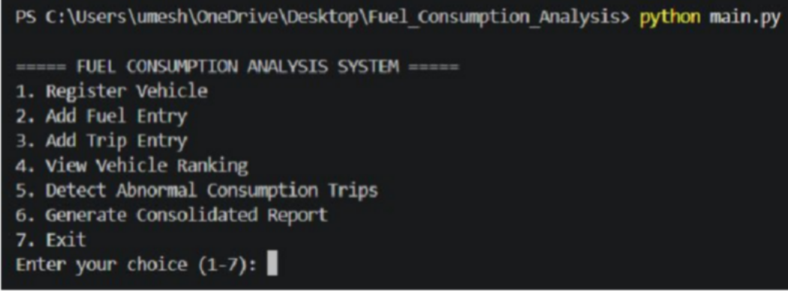
Figure 9.1: Main Menu of the Fuel Consumption Analysis System
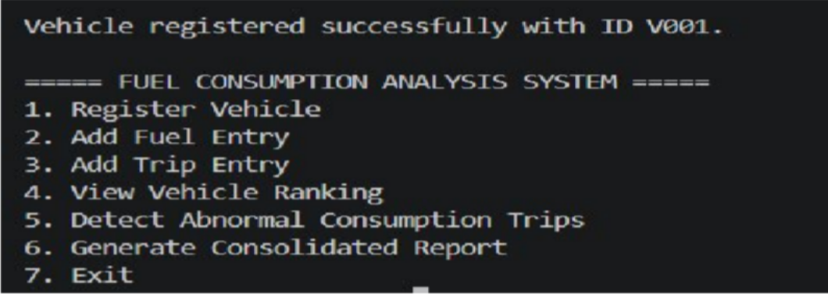
Figure 9.2: Vehicle Registration
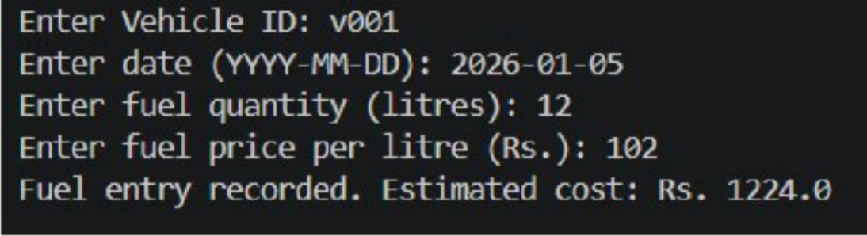

Figure 9.3: Fuel Entry

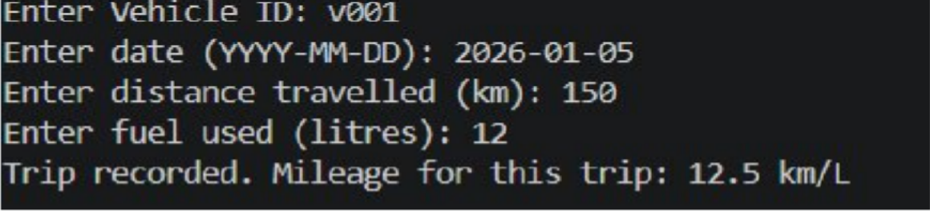
Figure 9.4: Trip Entry
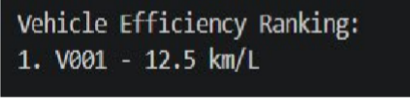
Figure 9.5: Mileage / Fuel-Efficiency Calculation
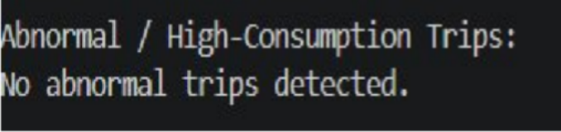
Figure 9.6: Vehicle Ranking
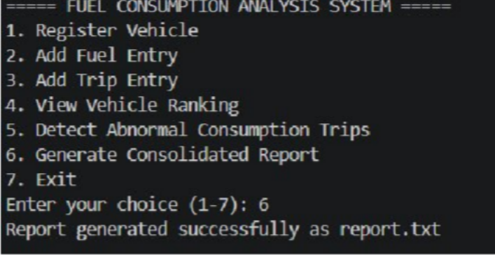
Figure 9.7: Abnormal Consumption Detection
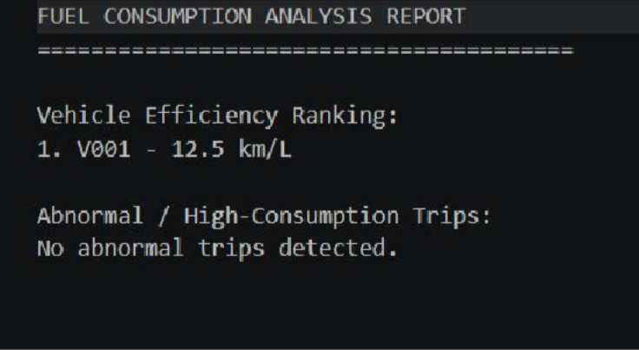

Figure 9.8: Final Consolidated Report

Results and Validation
This section presents sample results obtained by running the Fuel Consumption Analysis System on a realistic sample dataset consisting of four vehicles and six trips recorded over three months (January–March 2026). All figures below are consistent across tables and calculations.

Table 10.1: Vehicle Records

Vehicle ID | Vehicle Number | Vehicle Type | Total Distance (km) | Fuel Used (L) | Mileage (km/L)
V001 | TN01AB1234 | Car (Petrol) | 1200 | 100.0 | 12.00
V002 | TN02CD5678 | Motorcycle (Petrol) | 800 | 20.0 | 40.00
V003 | TN07EF4321 | Van (Diesel) | 1500 | 150.0 | 10.00
V004 | TN09GH8765 | Car (Diesel) | 1000 | 62.5 | 16.00

Table 10.2: Fuel Consumption Analysis

Vehicle | Distance (km) | Fuel Used (L) | Mileage (km/L) | Fuel Price (Rs./L) | Fuel Cost (Rs.)
V001 | 1200 | 100.0 | 12.00 | 102 | 10,200.00
V002 | 800 | 20.0 | 40.00 | 102 | 2,040.00
V003 | 1500 | 150.0 | 10.00 | 92 | 13,800.00
V004 | 1000 | 62.5 | 16.00 | 92 | 5,750.00
Total | 4500 | 332.5 | 13.53 (fleet) | - | 31,790.00

Table 10.3: Monthly Consumption

Month | Total Distance (km) | Total Fuel (L) | Average Mileage (km/L) | Total Fuel Cost (Rs.)
January 2026 | 1400 | 105.0 | 13.33 | 10,450.00
February 2026 | 1550 | 118.0 | 13.14 | 11,600.00
March 2026 | 1550 | 109.5 | 14.16 | 9,740.00
Total | 4500 | 332.5 | 13.53 (avg.) | 31,790.00

Table 10.4: Vehicle Efficiency Ranking

Rank | Vehicle | Mileage (km/L) | Efficiency Status
1 | V002 (TN02CD5678) | 40.00 | Most Fuel-Efficient
2 | V004 (TN09GH8765) | 16.00 | Efficient
3 | V001 (TN01AB1234) | 12.00 | Average
4 | V003 (TN07EF4321) | 10.00 | Least Fuel-Efficient

Table 10.5: Abnormal Consumption Detection
A trip is flagged as abnormal when its calculated mileage falls below 70% of the corresponding vehicle's average mileage.

Trip ID | Vehicle | Distance (km) | Fuel Used (L) | Calculated Mileage (km/L) | Status
T001 | V001 | 150 | 12.0 | 12.50 | Normal
T002 | V001 | 100 | 14.0 | 7.14 | Abnormal (High Consumption)
T003 | V002 | 200 | 5.0 | 40.00 | Normal
T004 | V003 | 300 | 35.0 | 8.57 | Abnormal (High Consumption)
T005 | V003 | 250 | 22.0 | 11.36 | Normal
T006 | V004 | 180 | 10.0 | 18.00 | Normal

Performance Metrics Summary

Metric | Value
Average fleet mileage | 13.53 km/L
Total fuel consumed | 332.5 L
Total distance travelled | 4500 km
Total fuel cost | Rs. 31,790.00
Best mileage | V002 – 40.00 km/L
Worst mileage | V003 – 10.00 km/L
Average monthly consumption | 110.83 L/month
Number of abnormal trips detected | 2 (T002, T004)

Graphical Results
The graphs below were generated from the sample dataset to visually summarise the analysis results.

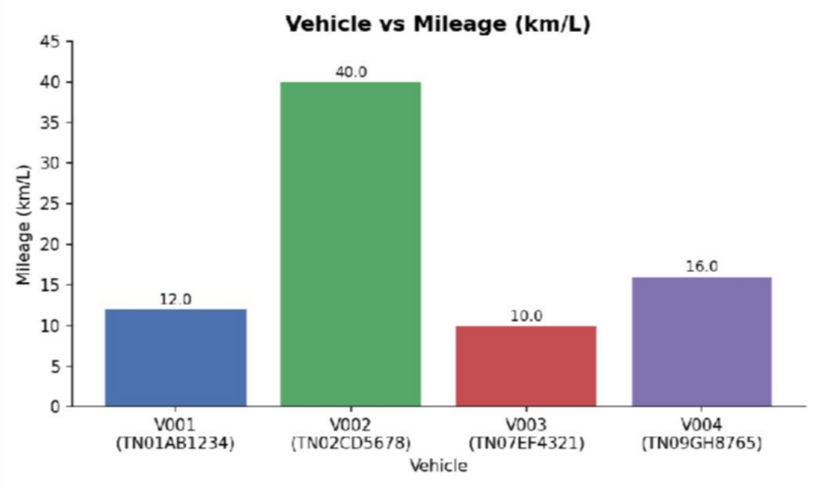
Figure 10.1: Vehicle vs Mileage (km/L)
This chart compares the mileage achieved by each vehicle. V002 (Motorcycle) shows the highest mileage at 40.00 km/L, while V003 (Van, Diesel) shows the lowest at 10.00 km/L, reflecting typical differences between vehicle categories.
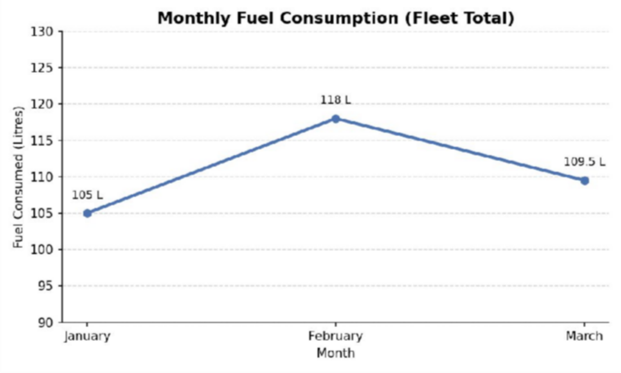
Figure 10.2: Monthly Fuel Consumption (Fleet Total)
This chart tracks total fuel consumed by the fleet across January, February and March 2026, showing a peak in February corresponding to the highest recorded trip activity.

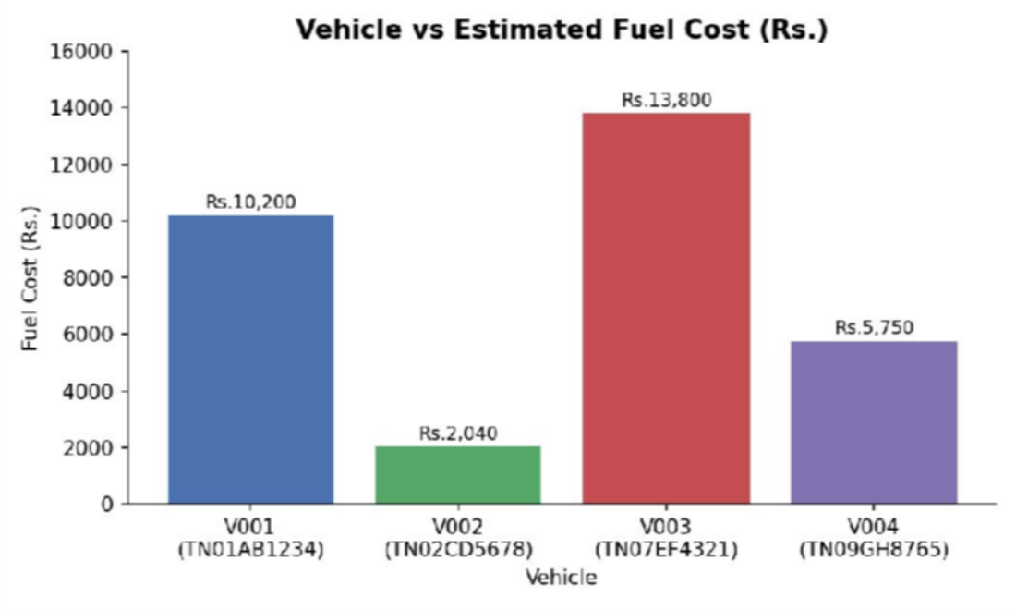
Figure 10.3: Vehicle vs Estimated Fuel Cost (Rs.)
This chart shows the estimated fuel cost incurred by each vehicle. V003 incurs the highest fuel cost due to its lower mileage and higher total distance, despite diesel being cheaper per litre than petrol.

Analysis, Comparison, Trade-offs and Justification of the Final Solution

Manual Tracking vs Python-Based Analysis
Manual fuel tracking using notebooks or spreadsheets requires the user to perform every calculation by hand, making it slow and error-prone as the number of vehicles and trips increases. The Python-based system automates mileage, cost and monthly-consumption calculations, removing arithmetic errors and instantly producing rankings and abnormal-trip alerts that would be very difficult to identify manually.

Benefits of the Chosen Approach
    - Automated calculations ensure consistent, error-free mileage, cost and consumption figures.
    - CSV persistence allows records to survive between program runs without requiring a database server.

    - Modular programming (data_manager.py and analysis.py) keeps storage logic separate from calculation logic, improving readability and maintainability.
    - Python data structures (lists, dictionaries, tuples, sets) allow efficient grouping, filtering and de-duplication of records.
    - The menu-driven interface is simple and requires no prior technical training to operate.
    - Accuracy and consistency are improved because every calculation follows the same validated formulas.
    - The modular design makes the system easy to maintain and extend with new features.
    - For the given data volumes, the console application performs all operations instantly with negligible processing time.

Trade-offs Considered

Trade-off | Discussion
CSV vs Database | CSV files are simple, human-readable and require no external setup, but lack the concurrency and query capabilities of a database. CSV was chosen for simplicity, appropriate to the scope of a Python programming assignment.
Console vs Web Application | A console application avoids the added complexity of web frameworks and is directly aligned with the CSA08 syllabus, which focuses on core Python programming rather than web development.
Simplicity vs Scalability | The current design favours simplicity and clarity of code over handling very large fleets; this is acceptable for individual users or small fleet operators, the intended audience.
Manual fuel-price input vs automatic price retrieval | Manual entry avoids dependency on external APIs or internet access, keeping the system self-contained, though it requires the user to keep prices up to date.
Basic threshold detection vs advanced statistical detection | A simple percentage-based threshold (70% of average mileage) is easy to understand and verify, whereas statistical methods (e.g., standard deviation-based outlier detection) would add complexity beyond the scope of this assignment.

Justification
The chosen solution is appropriate for a CSA08 Python Programming assignment because it directly demonstrates all four mapped Course Outcomes using core language features: menu-driven program structure (CO1), control flow, string handling and functions (CO2), the four fundamental data structures (CO3), and file handling with custom modules (CO4). The scope, complexity and technologies used are deliberately kept within the boundaries of a Python programming course, without introducing unrelated frameworks or platforms.

Broader Considerations

Sustainability and Environmental Impact
By making fuel-inefficient vehicles and wasteful trips visible, the system encourages users to adjust driving habits, perform timely vehicle maintenance, and retire or repair poorly performing vehicles. This directly supports fuel conservation and more responsible energy use at the individual or small-fleet level.

Data Accuracy, Privacy and Ethics
The accuracy of the system's outputs depends entirely on the accuracy of the data entered by the user; input validation reduces but does not eliminate this dependency. As the system stores vehicle numbers and usage data locally in CSV files, no data is transmitted externally, which supports user privacy. Users should be aware that vehicle numbers and trip patterns can be considered personally identifiable information and should be stored securely.

Accessibility, Usability and Scalability
The menu-driven console interface is simple enough for users without programming experience once the program is running, though it does require Python to be installed. The current design is best suited to individuals or small fleets; scaling to a large commercial fleet would require the improvements discussed in Section 13.

Real-World Fleet-Management Relevance
The core functions implemented here—vehicle registration, trip logging, mileage and cost analysis, and abnormal-consumption detection—mirror the fundamental capabilities of commercial fleet-management software, demonstrating how foundational programming concepts scale toward real-world applications.

SDG Connections
SDG 7 – Affordable and Clean Energy: By helping users identify inefficient vehicles and wasteful trips, the system supports more efficient use of fuel energy, reducing unnecessary consumption relative to distance travelled.
SDG 11 – Sustainable Cities and Communities: Encouraging efficient vehicle use and trip planning contributes to more sustainable urban transportation and reduced traffic-related resource waste.
SDG 13 – Climate Action: Reducing unnecessary or excessive fuel consumption directly reduces greenhouse gas emissions associated with vehicle use, contributing in a small but meaningful way to climate action goals.

Conclusion, Limitations and Possible Improvements

Conclusion
This project successfully designed and implemented a menu-driven Python console application for fuel consumption analysis. The system allows vehicles and trips to be registered and logged, automatically computes mileage, fuel cost and monthly consumption, ranks vehicles by efficiency, detects abnormally high-consumption trips, and persists all records to CSV files while generating a consolidated report. Sample data confirmed that all calculations are accurate and consistent across the tables and reports generated.
The system satisfies CO1 by implementing a structured, menu-driven console application using correct Python syntax; CO2 by using control flow, string handling and functions to validate input and compute metrics; CO3 by organising vehicle, trip and summary data using lists, dictionaries, tuples and sets; and CO4 by implementing file handling and custom modules to persist and reuse logic across the application.

Limitations

Limitation | Description
Console-based interface | No graphical user interface; usability is limited compared to modern applications.
CSV storage limitations | CSV files do not support concurrent multi-user access or complex queries.
Manual fuel-price entry | Fuel prices must be entered by the user rather than fetched automatically.
No GPS integration | Trip distances are entered manually rather than tracked automatically.
No real-time vehicle data | The system does not connect to onboard vehicle diagnostics or sensors.
Basic abnormal-consumption detection | Uses a simple percentage threshold rather than advanced statistical methods.
Limited scalability | Best suited to individuals or small fleets rather than large commercial operations.

Possible Improvements
    - Integrate a relational database (e.g., SQLite) for more robust and scalable storage.
    - Develop a web or mobile interface for improved accessibility.
    - Integrate real-time vehicle/GPS tracking for automatic distance logging.
    - Connect to a fuel-price API for automatic, up-to-date pricing.
    - Implement advanced statistical anomaly detection for abnormal-consumption trips.
    - Add a visualization dashboard for interactive exploration of results.
    - Deploy the system to a cloud platform for multi-user, remote access.

Individual Contribution of Group Members

S.No. | Student Name | Register Number | Contribution
1 | G. Umesh Chandra Yadav | 192525424 | Problem analysis, system design, Python implementation, testing, Data analysis, report generation, validation, documentation

References, Including Datasets and Software
Dataset note: This project uses a synthetic/sample dataset created for demonstration purposes; no external or public dataset was used.

References
- Python Software Foundation. Python 3 Documentation. https://docs.python.org/3/
- Python Software Foundation. csv — CSV File Reading and Writing. https://docs.python.org/3/library/csv.html
- Python Software Foundation. Reading and Writing Files. https://docs.python.org/3/tutorial/inputoutput.html
- Python Software Foundation. Errors and Exceptions. https://docs.python.org/3/tutorial/errors.html
- Python Software Foundation. Modules. https://docs.python.org/3/tutorial/modules.html
- United Nations. Sustainable Development Goals. https://sdgs.un.org/goals

Software and Tools Used
- Python 3.x
- Integrated Development Environment (VS Code / IDLE / PyCharm) – [insert actual IDE used]
- Microsoft Excel – for optional viewing/verification of generated CSV files

One-Page Individual Reflection

Individual Reflection
Working on the Fuel Consumption Analysis System gave me a practical understanding of how core Python programming concepts come together to solve a real-world problem. Early in the design process, I had to decide how to represent vehicle and trip data: I chose dictionaries for individual records because they let me label fields clearly (vehicle_id, distance_km, fuel_used_litres), while a set was the natural choice for enforcing unique vehicle numbers, since

sets automatically prevent duplicate entries. I also decided to represent fuel entries as tuples before writing them to CSV, since a single refuelling entry is a fixed, immutable set of values that does not need to change once recorded. This forced me to think carefully about which data structure best fits each part of the problem, rather than defaulting to lists everywhere.
One of the main challenges I faced was deciding how to detect “abnormal” fuel consumption in a way that was simple enough for a Python programming assignment but still meaningful. I initially considered fixed numeric thresholds, but these did not generalise well across different vehicle types with very different baseline mileages. I resolved this by comparing each trip's mileage to a percentage of that specific vehicle's own average mileage, which is easy to implement using functions and dictionaries and still produces sensible results. Another challenge was structuring the project into reusable modules; separating data_manager.py (storage) from analysis.py (calculations) took some refactoring, but it made the code considerably easier to test and reason about.
Through this assignment, I gained hands-on experience applying CO1 by building a structured, menu-driven console application; CO2 by writing validated, well-decomposed functions that handle control flow and string input; CO3 by using lists, dictionaries, tuples and sets appropriately rather than interchangeably; and CO4 by implementing file handling with CSV and organising the solution into custom, importable modules. Beyond the technical skills, the project deepened my appreciation for how something as simple as consistent fuel-consumption tracking connects to larger sustainability goals: it directly supports SDG 7 by promoting efficient energy use, SDG 11 by encouraging more sustainable transportation habits, and SDG 13 by helping reduce unnecessary emissions through better-informed driving and vehicle-maintenance decisions. Overall, this assignment reinforced that thoughtful use of basic programming constructs, applied consistently, can produce a genuinely useful analytical tool.

